SCHOOL OF COMPUTER SCIENCE AND ARTIFICIAL INTELLIGENCE |  |  |  |  | DEPARTMENT OF COMPUTER SCIENCE ENGINEERING
Program Name: B. Tech |  |  |  | Assignment Type: Lab |  |  | Academic Year:2025-2026
Course Coordinator Name |  |  |  | Dr. Rishabh Mittal
Instructor(s) Name
 |  |  |  | Mr. S Naresh Kumar
 |  |  |  | Ms. B. Swathi
 |  |  |  | Dr. Sasanko Shekhar Gantayat
 |  |  |  | Mr. Md Sallauddin
 |  |  |  | Dr. Mathivanan
 |  |  |  | Mr. Y Srikanth
 |  |  |  | Ms. N Shilpa
 |  |  |  | Dr. Rishabh Mittal (Coordinator)
 |  |  |  | Dr. R. Prashant Kumar
 |  |  |  | Mr. Ankushavali MD
 |  |  |  | Mr. B Viswanath
 |  |  |  | Ms. Sujitha Reddy
 |  |  |  | Ms. A. Anitha
 |  |  |  | Ms. M.Madhuri
 |  |  |  | Ms. Katherashala Swetha
 |  |  |  | Ms. Velpula sumalatha
 |  |  |  | Mr. Bingi Raju
CourseCode |  |  | 23CS002PC304 | Course Title |  | AI Assisted Coding
Year/Sem |  |  | III/II | Regulation |  | R23
Date and Day  of Assignment |  |  | Week6 – Monday | Time(s) |  | 23CSBTB01 To 23CSBTB52
Duration |  |  | 2 Hours | Applicable to Batches |  | All batches
Assignment Number: 11.1(Present assignment number)/24(Total number of assignments)
 | Q.No. | Question |  |  |  |  |  |  | Expected Time  to  complete
 | 1 | Lab 11 – Data Structures with AI: Implementing Fundamental Structures  Lab Objectives |  |  |  |  |  |  | Week6 - Monday

- Use AI to assist in designing and implementing fundamental data structures in Python.
- Learn how to prompt AI for structure creation, optimization, and documentation.
- Improve understanding of Lists, Stacks, Queues, Linked Lists, Trees, Graphs, and Hash Tables.
- Enhance code quality with AI-generated comments and performance suggestions.
Task Description #1 – Stack Implementation
Task: Use AI to generate a Stack class with push, pop, peek, and is_empty methods.
Sample Input Code:
class Stack: pass
Expected Output:
- A functional stack implementation with all required methods and docstrings.
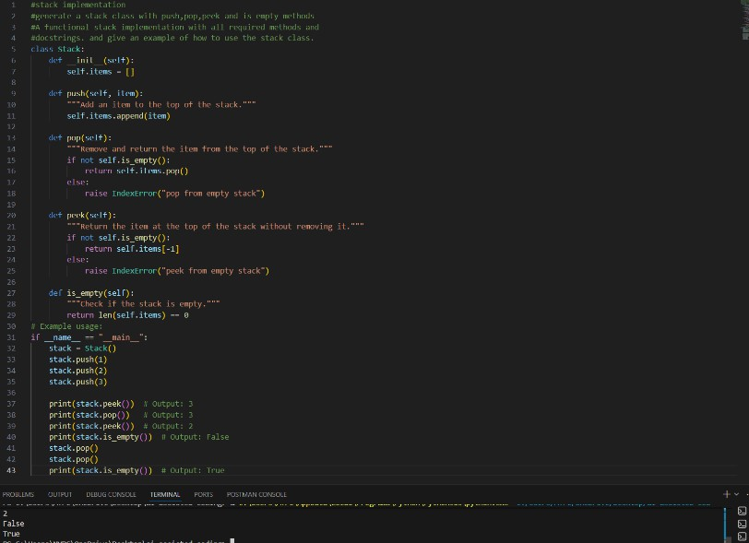

Task Description #2 – Queue Implementation
Task: Use AI to implement a Queue using Python lists. Sample Input Code:
class Queue: pass
Expected Output:
- FIFO-based queue class with enqueue, dequeue, peek, and size methods.

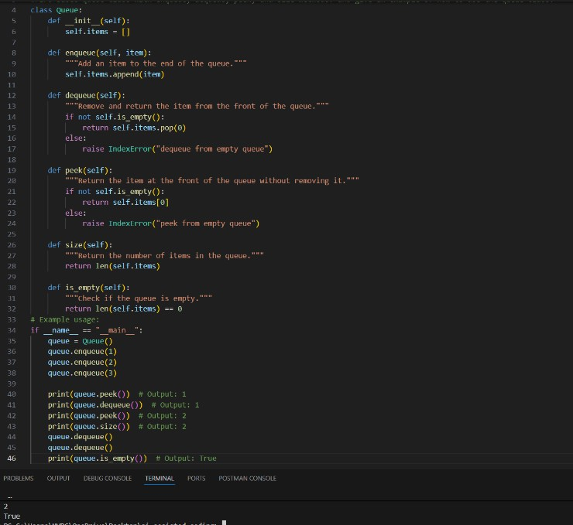
Task Description #3 – Linked List
Task: Use AI to generate a Singly Linked List with insert and display methods.
Sample Input Code:
class Node: pass

class LinkedList: pass
Expected Output:
- A working linked list implementation with clear method documentation.
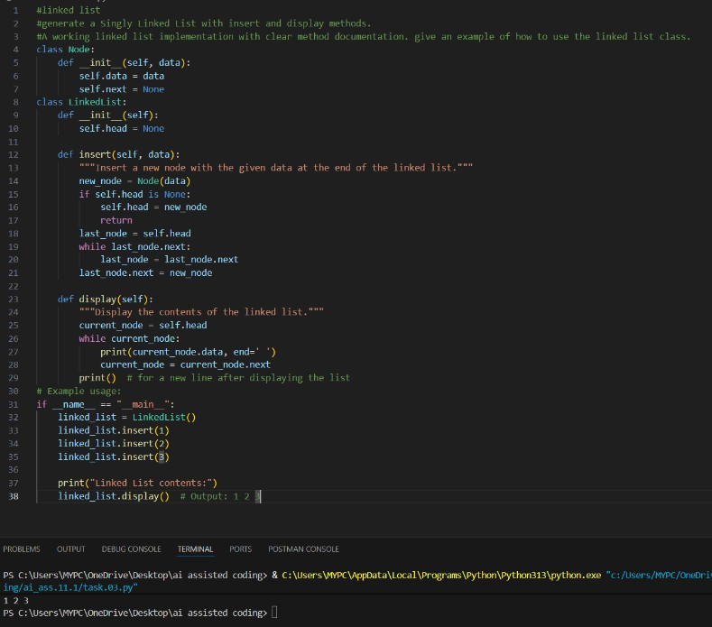

Task Description #4 – Binary Search Tree (BST)
Task: Use AI to create a BST with insert and in-order traversal methods. Sample Input Code:
class BST: pass
Expected Output:
- BST implementation with recursive insert and traversal methods.

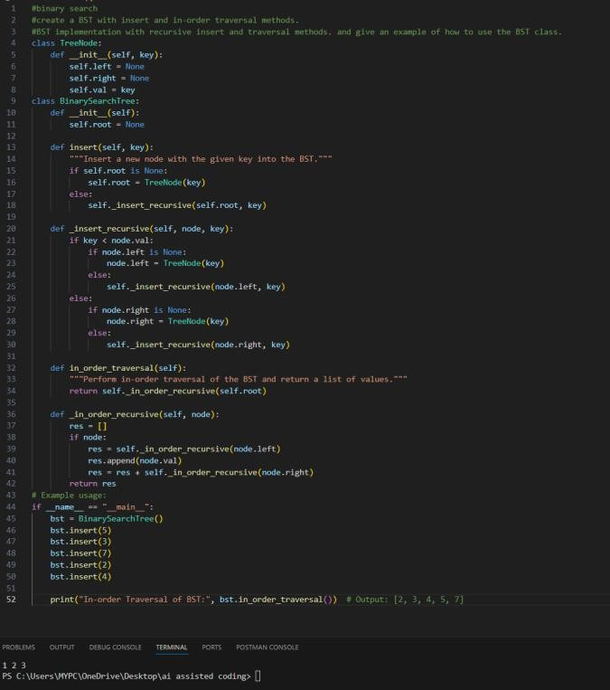

Task Description #5 – Hash Table
Task: Use AI to implement a hash table with basic insert, search, and delete methods.
Sample Input Code:
class HashTable: pass
Expected Output:
- Collision handling using chaining, with well-commented methods.

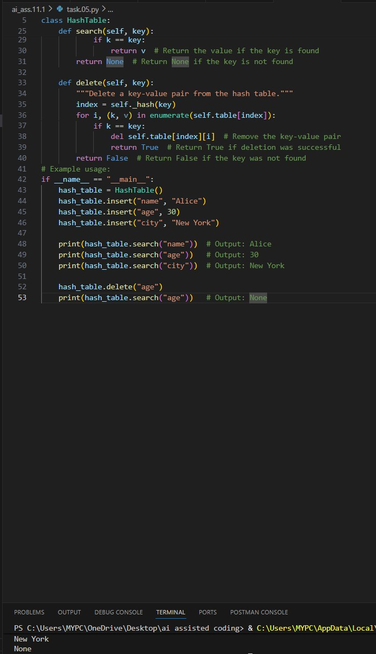
Task Description #6 – Graph Representation
Task: Use AI to implement a graph using an adjacency list. Sample Input Code:
class Graph: pass
Expected Output:
- Graph with methods to add vertices, add edges, and display connections.

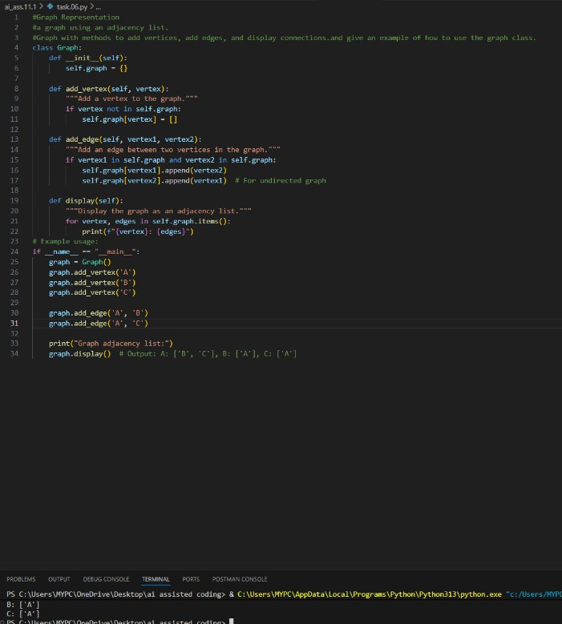
Task Description #7 – Priority Queue
Task: Use AI to implement a priority queue using Python’s heapq module.
Sample Input Code:
class PriorityQueue: pass
Expected Output:
- Implementation with enqueue (priority), dequeue (highest priority), and display methods.

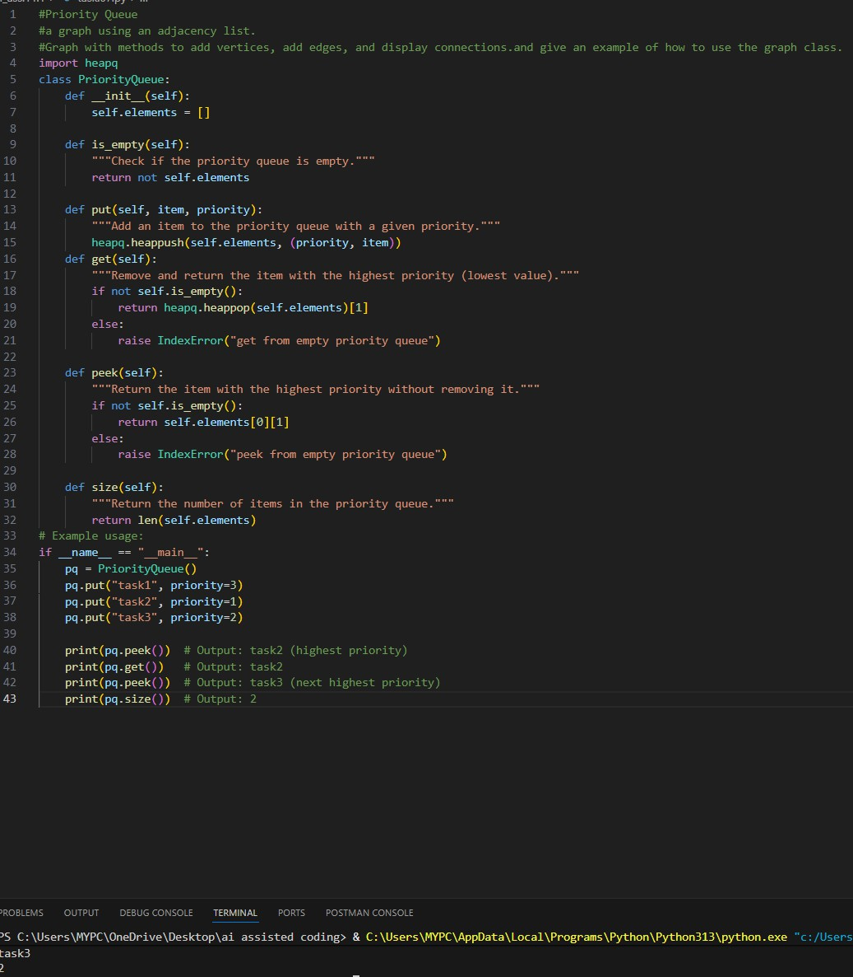
Task Description #8 – Deque
Task: Use AI to implement a double-ended queue using collections.deque.
Sample Input Code:
class DequeDS: pass
Expected Output:
- Insert and remove from both ends with docstrings.

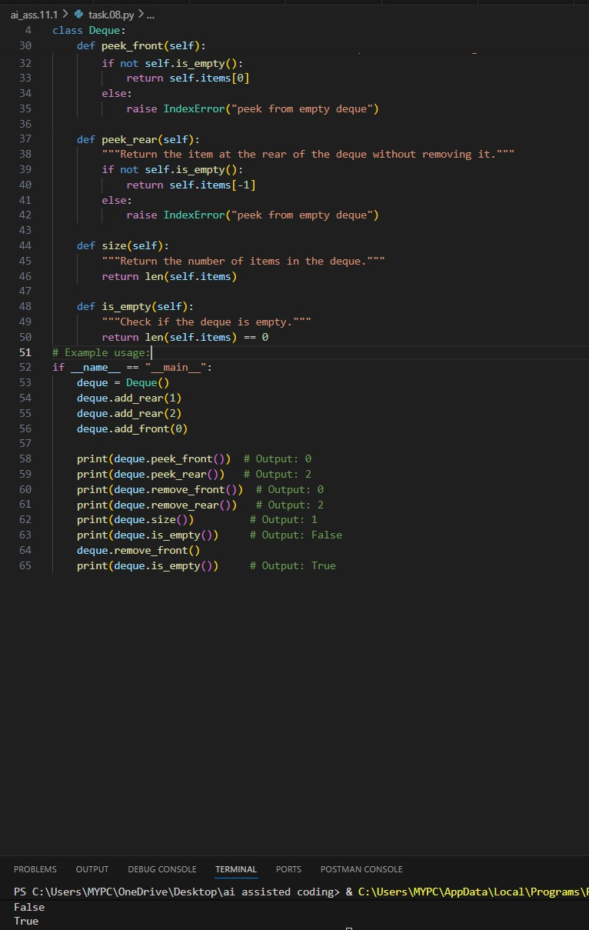
Task Description #9 Real-Time Application Challenge – Choose the Right Data Structure
Scenario:
Your college wants to develop a Campus Resource Management System that handles:
- Student Attendance Tracking – Daily log of students entering/exiting the campus.
- Event Registration System – Manage participants in events with quick search and removal.
- Library Book Borrowing – Keep track of available books and their

due dates.
- Bus Scheduling System – Maintain bus routes and stop connections.
- Cafeteria Order Queue – Serve students in the order they arrive.
Student Task:
  - For each feature, select the most appropriate data structure from the list below:
    - Stack
    - Queue
    - Priority Queue
    - Linked List
    - Binary Search Tree (BST)
    - Graph
    - Hash Table
    - Deque
  - Justify your choice in 2–3 sentences per feature.
  - Implement one selected feature as a working Python program with AI-assisted code generation.
Expected Output:
  - A table mapping feature → chosen data structure → justification.
  - A functional Python program implementing the chosen feature with comments and docstrings.

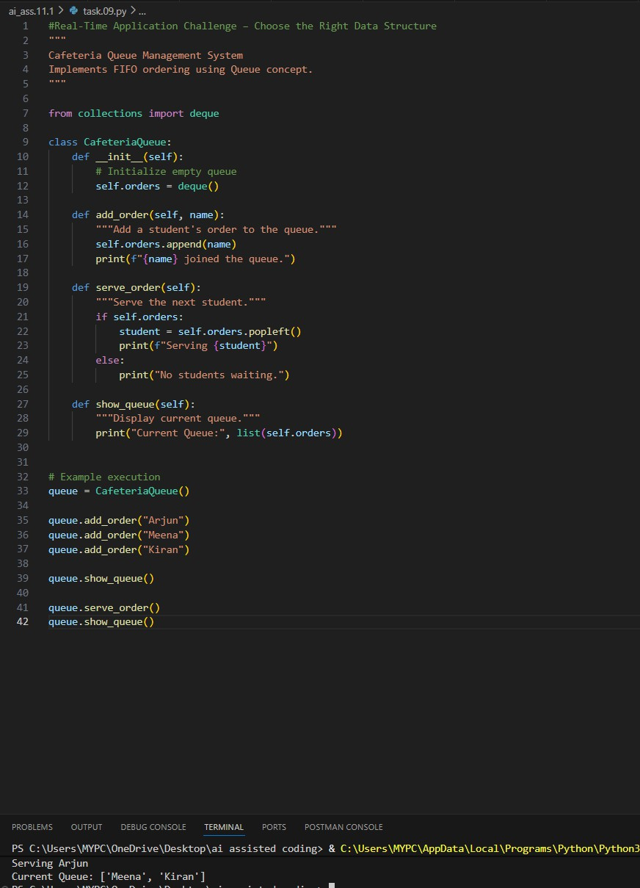

Task Description #10: Smart E-Commerce Platform – Data Structure Challenge
An e-commerce company wants to build a Smart Online Shopping System with:
- Shopping Cart Management – Add and remove products dynamically.
- Order Processing System – Orders processed in the order they are placed.

- Top-Selling Products Tracker – Products ranked by sales count.
- Product Search Engine – Fast lookup of products using product ID.
- Delivery Route Planning – Connect warehouses and delivery locations.
Student Task:
  - For each feature, select the most appropriate data structure from the list below:
    - Stack
    - Queue
    - Priority Queue
    - Linked List
    - Binary Search Tree (BST)
    - Graph
    - Hash Table
    - Deque
  - Justify your choice in 2–3 sentences per feature.
  - Implement one selected feature as a working Python program with AI-assisted code generation.
Expected Output:
  - A table mapping feature → chosen data structure → justification.
  - A functional Python program implementing the chosen feature with comments and docstrings.
